**TITLE**: Instruction for Inspection and Testing REF as well as ACTUAL CURRENT and VOLTAGE DPM PCB assembly (PA79/557/B) In Machine 600A (WITH SHUNT).(ERP CODE : **017.01.008.0287**)

1. **SCOPE :**
   1. Applicable for testing of REF as well as ACTUAL CURRENT and VOLTAGE DPM PCB ASSEMBLY. In Machine 600A (WITH SHUNT).
2. **DETAILS OF THE INSTRUCTION :**

2.1 Inspection / Measuring / Test Equipment. :

2.1.1 Digital Multimeter.

2.1.2 Wire boom for test.

2.1.3 External Variable DC Power Supply (0 to 50 Vdc).

2.1.4 Record the test results (OK / NOT OK) in the test report as the testing progress.

(REF: INSP4591/I5/R0).

**2.2** **VISUAL INSPECTION:**

* + 1. Check the sticker for software version number, it should be proper.
    2. Check the short link for model selection whether appropriate short link is put on the model selection link LK3 (Max Current 600A).

**2.3** **ELECTRICAL TEST:**

**NOTE: After testing keep toggle switches and knobs to their default position.**

**NO LOAD TEST:**

* + 1. Switch ON power supply of TEST JIG***.***
    2. Keep SHUNT/HALL SENSOR switch to SHUNT position and REF/CUR switch on test jig to CUR position.
    3. Vary Feedback Current POT from MIN to MAX position and check voltage at respective test point (from 0mV-75mV).
    4. Keep SHUNT/HALL SENSOR switch to HALL SENSOR position and

REF/CUR switche of test jig to REF position.

* + 1. Vary Feedback current POT from MIN to MAX position and check voltage at

Respective test point (from 0V- 4V).

* + 1. Connect the PCB under test, as per the given wiring diagram

(Test jig PA79/906/A). Switch ON the power supply.

* + 1. Program the TEST PCB (For programming refers **DSGN2004/I4/R0**.).

***(Microcontroller – PIC16F886 and Programming connector CN1 on TEST PCB)***

**Note: Ensure the correct software revision is displayed during power on of PCB**

* + 1. Now check the voltage levels at the test points with respect to ground (TP2) as follows on Test PCB.

|  |  |
| --- | --- |
| **TEST POINT** | **VOLTAGE** |
| TP1 | +5 Volt |
| TP2 | GND |
| TP4 | 0V |
| TP5 | 0V |

**REFERENCE CURRENT CALIBRATION**:

* + 1. Connect the external DC Power Supply to CN2 of test PCB (CN2-6 to +VE terminal and CN2-3 to –VE terminal of DC power supply.) and set it to 50Vdc. Now switch off the external DC power supply and then supply of test jig.
    2. Keep SHUNT/HALL SENSOR switch of test jig to HALL SENSOR position and

REF/CUR switch of test jig to REF position.

* + 1. Switch ON power supply of TEST JIG and then Switch on the external DC supply. Vary Feedback current POT from MIN to MAX position (0.75V to 4V); DPM will show set reference current 10 to 600(DISP 1, 2, 3, 4). Maximum value should be calibrated by **Preset ‘P4’.**

**FEEDBACK CURRENT CALIBRATION**:

* + 1. Keep feedback current POT at MIN position. Keep SHUNT/HALL SENSOR switch to SHUNT position.
    2. Keep REF/CUR switch of DPM to CUR position. Switch off the external DC power supply and supply of test jig.
    3. Switch ON power supply of TEST JIG. Switch on the power supply of external DC supply. Adjust feedback current pot on TEST JIG at position such that it shows (75mV) on multimeter connected at banana terminals above pot. DPM shows Max current 600A (DISP 1, 2, 3, 4). Maximum value should be calibrated by **Preset ‘P1’.**

2.3.8 Now verify the voltage @ TP5 of test PCB by varying feedback current pot of TEST JIG from min to max and check the voltage at respective test point.

For 0-75mV output for 600 Amp:

**Note**: External Dc supply must be set to 50Volt for feedback current calibration if supply is off or less than 40Volt Err-004 will appear on test pcb.

|  |  |  |
| --- | --- | --- |
| Input feedback voltage @ respective test point on TEST JIG. | Voltage @ TP5 w.r.t. ground (i.e.TP2) on Test PCB. | Output on display |
| 0 / 0 V | 0 to 0.15 V | 10 |
| 1 / 25mV | 1 to 1.2 V | 200 (+/- 5) |
| 2 / 50mV | 2 to 2.2 V | 400 (+/- 5) |
| 3 /75mV | 3 to 3.2 V | 600 (+/- 5) |

**FEEDBACK VOLTAGE CALIBRATION (Lower 4 Digit)**:

* + 1. Keep the feedback current knob at max position (75mv and switch at CUR position).
    2. Ensure that external DC supply is set to 50Vdc. DPM will show the 50.00 on lower 4 seven segments (DISP 5,6,7,8). Calibrate this using **Preset ‘P3’**.
    3. Now verify the voltage @ TP4 of test PCB as per table given below by varying external DC power supply from 10 to 50 Volt.

|  |  |  |
| --- | --- | --- |
| Input feedback voltage @ External Regulated DC supply. | Voltage @ TP4 w.r.t. ground (i.e.TP2) on Test PCB. | Output on display |
| 0 / 10 V | 0.3 to 0.5 V | 10 (+/- 3) |
| 1 / 20 V | 0.6 to 0.8 V | 20 (+/- 3) |
| 2 / 30 V | 0.9 to 1.1 V | 30 (+/- 3) |
| 3 / 40V | 1.2 to 1.4 V | 40 (+/- 3) |
| 4/50V | 1.5 to 1.7 V | 50(+/-3) |

* + 1. Set voltage on external dc power source to 30Volt and feedback current knob to minimum value. Display will show the ‘Err-0004’ i.e. no OCV error.

**KEY FUNCTIONALITY**

* + 1. Press switch ‘SW1’ display will show following message for 1 Sec:

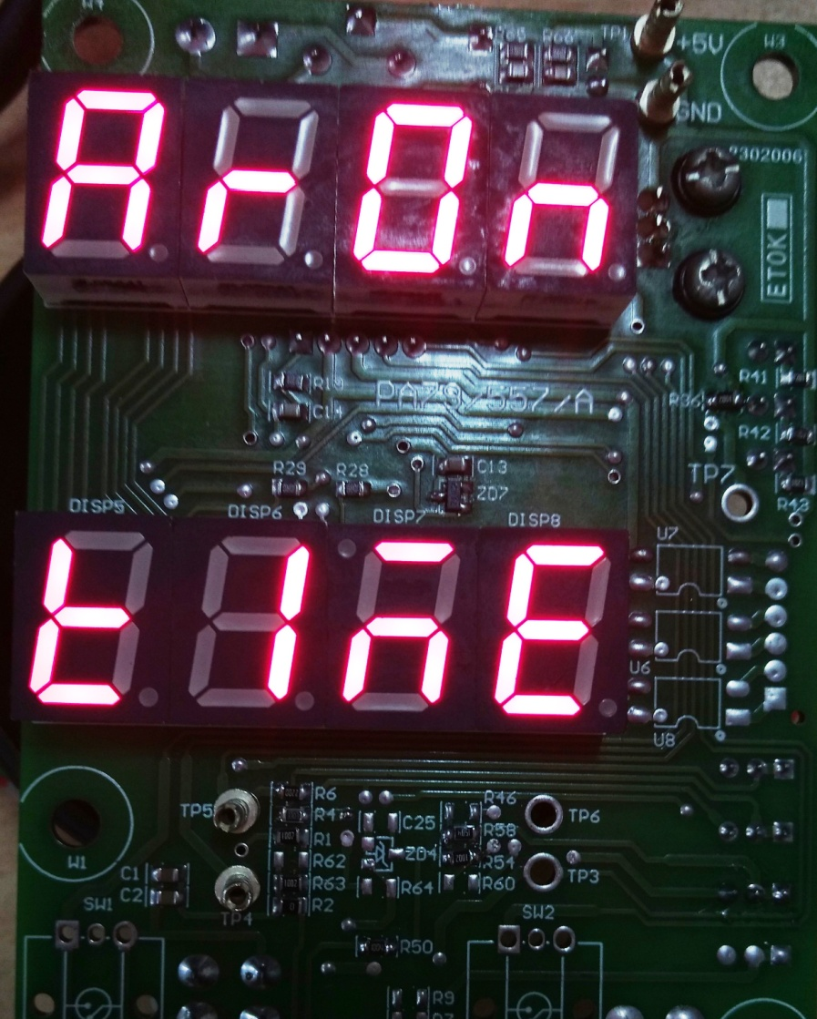

Followed by

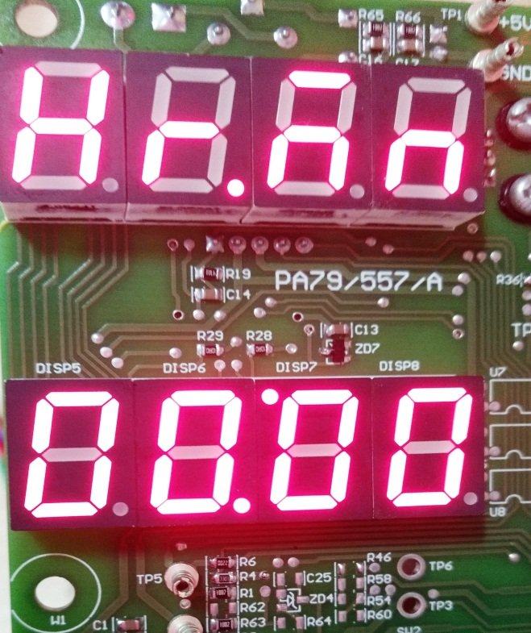

(Note: This is arc on time so actual lower digit value may not match with as shown in picture above.)

* + 1. Press switch ‘SW2’ display will flash the following message for 5 Sec followed by next message as shown in figures below:

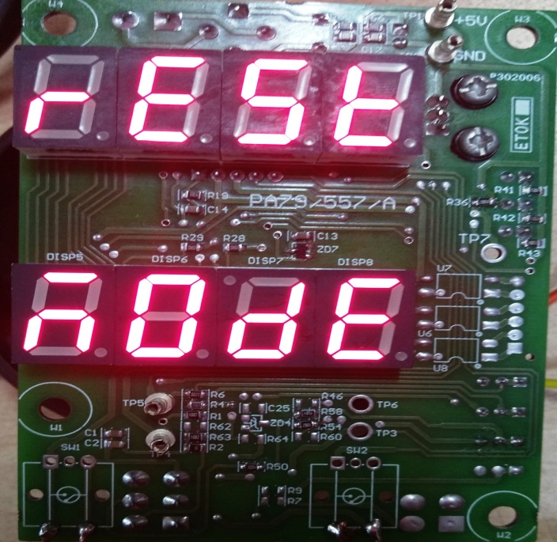

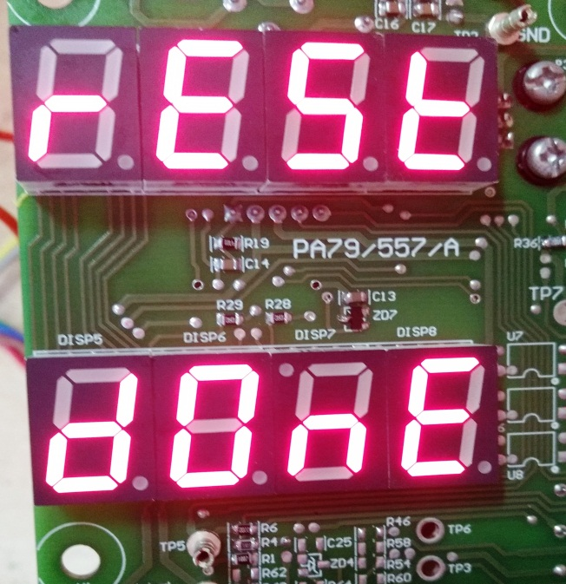

**Prepared By, Approved By,**

**Akshay Nirgude Mr. Sachin Dobhada**

(05-03-2018)